`

Student Name | SOLUTIONS
Teacher | GSL | MDI | HAL | SMH

CHEMISTRY
Unit 3, SAC 1: Task 2
Written report on investigation and test on concepts from
AOS1: What are the options for energy production?
Chapters 1-6 of Heinemann Chemistry 2
Monday 23 March, Period 4
Reading time: 5 minutes
Writing time: 65 minutes

Structure of SAC
Task and Section | Number of questions | Number of questions to be answered | Number of marks
Task 1 | Investigation already completed |  | Hurdle
Section A Written Report | 1 | 1 | 9
Section B Multiple Choice Questions | 8 | 8 | 8
Section C Short Answer Questions | 3 | 3 | 28
Task 2 |  |  | Total 45

- Students are permitted to bring into the assessment room: pens, pencils, highlighters, erasers, sharpeners, rulers and one scientific calculator.
- Students are not permitted to bring into the examination room: blank sheets of paper and/or white out liquid/tape.
Materials supplied
- This question and answer book of 13 pages.
- A data book
- Student’s Task 1 results booklet
Instructions
- Write your name in the space provided above on this page.
- All responses must be written in English.
- Working out must be shown for all calculations
- Do NOT write on the data book
At the end of the assessment session
- Wait silently for the supervisor to collect your Task 1 & 2 booklets and data book.
Students are NOT permitted to bring mobile phones and/or any other unauthorised electronic devices into the examination room.
Students must not disclose the contents of the task; to do so will be a breach of VCE guidelines and will be dealt with according to VCAA regulations.

SECTION A Written Report

Instructions for Section A
Answer all questions in the spaces provided. Write using black or blue pen.
To obtain full marks for your responses you should:
- Give simplified answers with an appropriate number of significant figures to all numerical questions; un-simplified answers will not be given full marks.
- Show all working in your answers to numerical questions. No marks will be given for an incorrect answer unless it is accompanied by details of the working.
- Make sure chemical equations are balanced and that the formulas for individual substances include an indication of state; for example, H₂(g), NaCl(s).

Question 1 Analysis and Evaluation (9 marks)
The following questions relate to the practical investigation carried out in Task 1.

- The electrochemical series below was created using student results from Task 1. Results have been averaged and outliers removed. Use this information to answer Questions 1a.i. to iv.

Reaction Electrode potential (V)
Fe³⁺(aq) + e⁻ → Fe²⁺(aq) +0.45
I₂(aq) + 2e⁻ → 2I⁻(aq) +0.26
Cu²⁺(aq) + 2e⁻ → Cu(s) 0.00
Zn²⁺(aq) + 2e⁻ → Zn(s) -0.56

- Identify the strongest reducing agent in this electrochemical series.

Zn or zinc or Zn(s)
1 mark

- Use this series to predict the half-equations and overall equation for a cell with I₂/I⁻ and Zn²⁺/Zn half-cells.

Anode reaction | Zn(s) → Zn²⁺(aq) + 2e⁻
Cathode reaction | I₂(aq or s) + 2e⁻ → 2I⁻(aq)
Overall reaction | I₂(aq or s) + Zn(s) → Zn²⁺(aq) + 2I⁻(aq)
3 mark
1 mark correct oxidation and reduction half equations
1 mark correct anode and cathode half equations (consequential)
1 mark correct overall equations (consequential)
States not required

- Calculate the expected voltage of the I₂/I⁻ and Zn²⁺/Zn galvanic cell in Question 1a.ii. using the electrode potential values from the electrochemical series above.
+0.26 V - -0.56 V = 0.82 V
Units required.
1 mark

- Suggest a reason why the value in Question 1a.iii. is different from the theoretical voltage for the same galvanic cell calculated using the electrode potentials in Table 2 of the Data Book?

One of:
specify valid experimental error
or
non-standard conditions
or
different solution concentrations (1.0M and 0.1M)

VCAA requires that you quote the 1.0M, 25ºC and 100 kPa values when referring to standard laboratory conditions.
Whilst small changes in temperature may occur during the experiment, these do not materially change the voltage. We are seeking your best answers to this question.
1 mark

- Voltages measured for the cell with Fe³⁺/Fe²⁺ and Cu²⁺/Cu half cells are listed below for five different student groups.
+0.45 V | +0.44 V | +0.45 V | +0.44 V | +0.46 V

Discuss the reliability of these five results.
Reproducibility is the part of reliability that relates to the closeness of results when different groups conduct an experiment. The small difference in these results is consistent with reproducible and reliable results. (1 mark all underlined parts)
1 mark

- Identify one potential source of random error in the experiment that you conducted during Task 1 and explain how the method could be improved to reduce this error.
One of:
Fluctuations in voltmeter voltages. (1 mark) Repeat the experiment and average the results, or use a more precise voltmeter. (1 mark)
or
Build-up of deposits on the electrodes. (1 mark) Clean the electrodes before measuring the voltage. (1 mark)
or
Changes in the concentration of solutions caused by side reactions. (1 mark) Use batches of fresh solutions. (1 mark)
or
Other valid random error. (1 mark) Valid improvement relating to this random error. (1 mark)

Whilst small changes in temperature may occur during the experiment, these do not materially change the voltage. We are seeking your best answers to this question.
2 marks

End of Section A

SECTION B: Multiple-choice questions
Instructions for Section B
Answer all questions in pencil on the answer sheet provided for multiple choice questions.
Choose the response that is correct or that best answers the question.
A correct answer scores 1, an incorrect answer scores 0.
Marks will not be deducted for incorrect answers. No marks will be given if more than one answer is completed for any question.
The following information relates to Questions 1 to 3.
Loy Yang is Australia’s largest coal-fired power station. The heat of combustion of brown coal from the Loy Yang mine is 8.0 MJ kg⁻¹. A diagram showing the energy conversions for the power station is shown below.
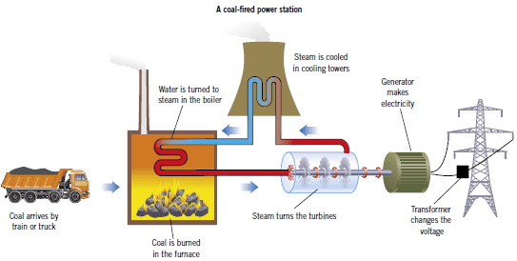
Water is turned into steam in the boiler
Generator makes electricity
Generator makes electricity
Generator makes electricity
Steam turns the turbine
Coal is burnt in the furnace
Question 1
The main energy transfers in the Loy Yang power station are best described as
- Chemical energy to thermal energy of burning coal to thermal energy of steam to electrical energy
- Chemical energy to mechanical energy to electrical energy
- Chemical energy to thermal energy of burning coal to thermal energy of steam to mechanical energy to electrical energy
- Thermal energy of burning coal to thermal energy of steam to mechanical energy to electrical energy
C
Question 2
Loy Yang brown coal contains 60% by mass water and, as a consequence, is a low energy content fuel. When completely combusted in the power station, 1.0 kg of this brown coal produces 0.88 kg of carbon dioxide. The carbon intensity of this fuel, in kg of CO₂ per MJ of energy, is
- 7.0
- 0.88
- 1.1
- 0.11
D
Heat of combustion $=\frac{8.0MJ}{1.0kg coal}$ and $\frac{0.88kg of CO2}{1.0kg coal}$
Therefore carbon intensity of coal $=\frac{0.88kg CO2}{8.0MJ}=$0.11kg CO₂/MJ
Question 3
The energy conversion efficiency of the Loy Yang power station is 34%. Given the Loy Yang power station produces 2.6 × 10⁸ MJ of electrical energy daily, the daily mass, in kg, of coal consumed by this power station would be closest to
- 1.1 x 10⁷
- 9.0 x 10⁷
- 7.6 x 10⁸
- 9.4 x 10⁷
D
Chemical energy in 1 kg of coal converted into electricity $=\frac{8.0MJ/kg}{0.34}=2.72MJ/kg$
Daily coal requirement $=\frac{2.6 × 10^8 MJ}{2.72MJ/kg}=95588235kg=9.6x{10}^{7}kg$
Question 4
One proposal to reduce greenhouse gas emissions from coal-fuelled power stations involves capturing carbon dioxide and storing it deep underground in a supercritical (liquid-like) state. 1.2 kg of supercritical carbon dioxide occupies a volume of 1.0 L. In contrast, 1.2 kg of carbon dioxide gas at standard laboratory conditions would occupy a volume, in L, of
- 25
- 676
- 30000
- 30
B
n(CO₂) $=\frac{m}{M}=\frac{1.2kg×1000}{12.0+2×16.0g{mol}^{-1}}=27.3mol$
V(CO₂) $=nV_{m}=27.3mol×24.8L{mol}^{-1}=676L=6.8×{10}^{2}L$
Question 5
The iodate ion, IO₃–, is a strong oxidant that will form iodine, I₂, when it reacts. The half-equation that would best describe how this ion would react in acidic solutions would be:
- 2IO₃–(aq) + 6H⁺(aq) + 4e– → I₂(aq) + 6H₂O₂(aq)
- 2IO₃–(aq) + 6H₂O(l) + 10e– → I₂(aq) + 12OH–(aq)
- 2IO₃–(aq) + 10e– → I₂(aq) + 6O^{2–}(aq)
- 2IO₃–(aq) + 12H⁺(aq) + 10e– → I₂(aq) + 6H₂O(l)
D
KOHES
Question 6
A group of students assembled the apparatus as shown in the diagram for an experiment to determine the enthalpy of combustion for butane [M = 58.0 g mol⁻¹].
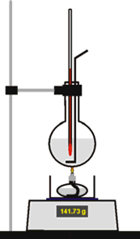
The students reported the following data:
Mass of water 100 g
Mass of fuel burnt 0.573 g
Increase in temperature 28.33°C

From these data, the calculated molar enthalpy of combustion,
in kJ mol⁻¹, would be
- 11800
- 1200
- 11.8
- 2880
B
q(water) = mc∆T = 100g x 4.18Jg⁻¹K⁻¹ x 28.33K = 11 842J
n(butane)$=\frac{m}{M}=\frac{0.573g}{58.0g{mol}^{-1}}=9.879×{10}^{-3}mol$
molar enthalpy of combustion $=\frac{11 842J}{9.879x10^-3mol}=1198662J=$1200kJ
Question 7
When comparing a fuel cell with a galvanic cell, one major difference is that in fuel cells
- the potential difference will always be about 2V.
- the polarity of the cathode is the opposite of that on a galvanic cell.
- the energy conversion is more efficient.
- the oxidant and reductant are continually being replaced.
D
Question 8
Mr Gear fuels his car with bioethanol. The thermochemical equation at SLC for its complete combustion is
C₂H₅OH(l) + 3O₂(g) → 2CO₂(g) + 3H₂O(l) ΔH = –1360 kJ mol^{–1}
Heptane is a component of petrol, used in most cars. The thermochemical equation at SLC for the complete combustion of heptane is
C₇H₁₆(l) + 11O₂(g) → 7CO₂(g) + 8H₂O(l) ΔH = –4825 kJ mol^{–1}
Which one of the following statements is the most correct?
- The heat energy released by ethanol will not be affected if the oxygen supply is limited.
- Ethanol releases more energy per gram on combustion at SLC than heptane.
- Bioethanol is a non-renewable fuel.
- Burning 1.0 g of heptane at SLC releases 48 kJ of heat energy.
D
Energy released per gram of ethanol $29.6Jg^{-1}$ (databook)
Energy released per gram of heptane = $\frac{∆H}{M}=\frac{4825 kJ {mol}^{-1}}{7×12.0+16×1g{mol}^{-1}}=48.3kJ$

END OF SECTION B
Section B: Multiple Choice Answer Sheet
This answer sheet must not be detached from this booklet.

INSTRUCTIONS FOR MULTIPLE CHOICE ANSWER SHEET
Use a PENCIL for ALL entries. For each question, shade the box which indicates your answer.
Marks will NOT be deducted for incorrect answers.
NO MARK will be given if more than one answer is completed for any question.
If you make a mistake, ERASE the incorrect answer - DO NOT cross it out.

1 |  | A |  | B |  | C |  | D
2 |  | A |  | B |  | C |  | D
3 |  | A |  | B |  | C |  | D
4 |  | A |  | B |  | C |  | D
5 |  | A |  | B |  | C |  | D
6 |  | A |  | B |  | C |  | D
7 |  | A |  | B |  | C |  | D
8 |  | A |  | B |  | C |  | D

SECTION C Short Answer Questions

Instructions for Section C
Answer all questions in the spaces provided. Write using black or blue pen.
To obtain full marks for your responses you should:
- Give simplified answers with an appropriate number of significant figures to all numerical questions; un-simplified answers will not be given full marks.
- Show all working in your answers to numerical questions. No marks will be given for an incorrect answer unless it is accompanied by details of the working.
- Make sure chemical equations are balanced and that the formulas for individual substances include an indication of state; for example, H₂(g); NaCl(s)

Question 1 (13 marks)
A vehicle that is powered by a diesel engine is able to use either petrodiesel or biodiesel as a fuel. Petrodiesel and biodiesel are not pure substances, but are a mixture of molecules.
The table below lists some of the properties of the two fuels.
Fuel | Major component | Energy content  (MJ/kg)
petrodiesel | C₁₂H₂₆ | 43
biodiesel | C₁₉H₃₂O₂ | 38

- Describe and explain the difference in cloud point, under the same conditions, of the two fuels and how this would affect the flow of each fuel at low temperatures.
Claim – Biodiesel has a higher cloud point than petrodiesel.

Evidence – Biodiesel is a larger molecule than petrodiesel. It has more electrons and more readily forms temporary/instantaneous dipoles resulting in stronger dispersion forces than petrodiesel. It also has a polar ester functional group resulting in strong dipole-dipole attractions between biodiesel molecules. (1 mark, saturation and kinking could also affect dispersion forces strength)

Explain – Cloud point is the temperature below which crystals form in liquid fuels. The cloud point of biodiesel is higher than petrodiesel because the intermolecular bonding is stronger. (1 mark)

This may restrict fuel flow through filters and injectors at low temperatures. (1 mark)

3 marks

- How much energy is released, in MJ, during the combustion of 50 L of petrodiesel?
density (petrodiesel) = 0.83 kg L^{–1}.
m = dV = 0.83kgL^{–1} x 50L = 41.5kg (1 mark)
energy = 41.5kg x 43MJkg⁻¹ = 1785MJ = 1800MJ or 1.8 x 10³MJ (1 mark)
Minus 1 mark for incorrect significant figures
Units not required

2 marks

- Write a balanced chemical equation for the complete combustion of the major component of biodiesel, C₁₉H₃₂O₂.
C₁₉H₃₂O₂(l) + 26O₂(g) → 19CO₂(g) + 16H₂O(g or l) (1 mark balanced equation, 1 mark states)
2 marks

- The molar heat of combustion of C₁₉H₃₂O₂ is 11 096 kJ mol⁻¹ and activation energy 200 kJ mol⁻¹. Complete the diagram below to show the energy profile for the combustion of C₁₉H₃₂O₂ and label:
  - the molar heat of combustion ΔH; (should have read “the molar enthalpy of combustion ΔH”, both negative and positive awarded below)
  - the activation energy E_{a}; and
  - the reactants and products.

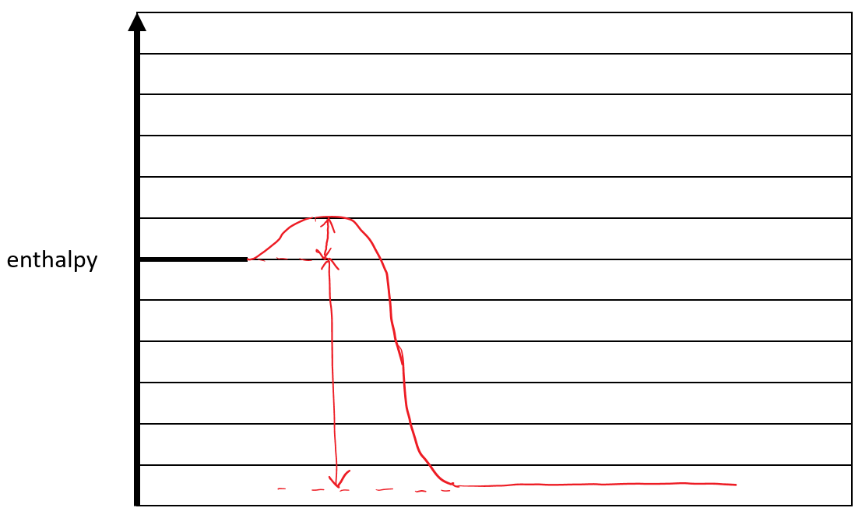

C₁₉H₃₂O₂(l) + 27O₂(g)
Ea 200 kJ or kJmol⁻¹

∆H -11 096 or 11 096 kJ or kJmol⁻¹

19CO₂(g) + 16H₂O(g)

3 marks
1 mark profile shape
1 mark reactants and products shown with states (consequential)
1 mark ∆H and Ea values labelled with units
(values and units can be shown on a correctly scaled enthalpy axis)

- Compare the environmental impacts of the production of petrodiesel and biodiesel.

Petrodiesel comes from crude oil extracted from underground reservoirs. Extraction/transport/refining of crude oil use energy. Biodiesel comes from animal fats and plant oils. Farming/transport/production use energy. (1 mark)

1 mark for any one of:

Growing plants for biodiesel (or animal feed) removes carbon dioxide from the atmosphere. As a result, net carbon dioxide emissions to the atmosphere during the production of biodiesel are lower than for petrodiesel. (1 mark)

Biodiesel crops consume water/fertiliser/resources and/or displace food crops. (1 mark)

If farming/transport/production energy is from a fossil fuel source, generation of the energy releases carbon dioxide into the atmosphere. Carbon dioxide is a greenhouse gas that contributes to global warming. (1 mark)

Biodiesel is a renewable fuel/sustainable. (1 mark)

1 mark for any one of:

If extraction/transport/refining energy is from a fossil fuel source, generation of the energy releases carbon dioxide into the atmosphere. Carbon dioxide is a greenhouse gas that contributes to global warming. (1 mark)

Oil spills during production have the potential to harm the surrounding ecology. (1 mark)

Petrodiesel is a non-renewable fuel/unsustainable. (1 mark)

3 marks

Question 2 (8 marks)
Galvanic cells use redox reactions to produce electrical energy.

- Galvanic cells are usually composed of two separate half-cells connected by a wire and salt bridge.
  - Explain why is it necessary to use separate half-cells for the oxidation and reduction reactions in order to produce electrical energy?
Half cells separate the reductant and oxidant, with electron transfer occurring through the external circuit. If these were in contact, the energy released during the transfer of electrons between the reductant and oxidant would be in the form of heat, and not electrical energy.

1 mark

  - What is the role of the salt bridge in a galvanic cell?
Ions flow through the salt bridge to ensure electroneutrality in the individual half-cells.

1 mark

- Two galvanic cells (A and B) were set up in the laboratory under standard conditions.
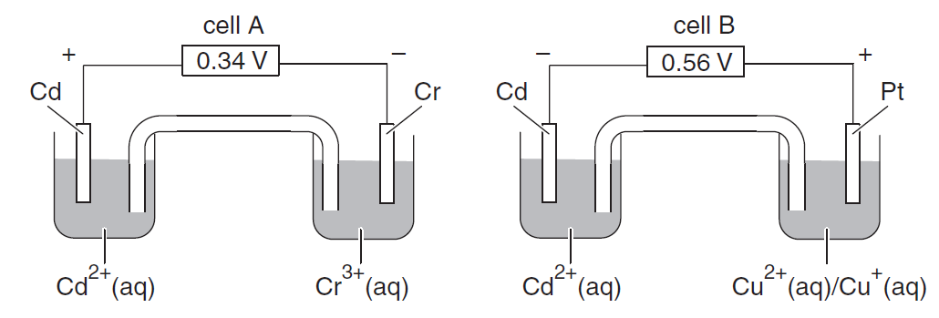
  - Identify the cathode in cell A.
According to An Oil Rig Cap, the cathode has a positive polarity.

Cadmium or Cd or Cd(s)
1 mark

  - Write the half-equation for the oxidation reaction in cell A.
According to An Oil Rig Cap, oxidation occurs in the Cr³⁺/Cr half-cell at the negative electrode.

Cr(s) → Cr³⁺(aq) + 3e⁻ (states not required)
1 mark

  - Write the chemical equation for the overall redox reaction in cell A.
Cr(s) → Cr³⁺(aq) + 3e⁻ x2
Cd²⁺(aq) + 2e⁻ → Cd(s) (1 mark) x3

2Cr(s) + 3Cd²⁺(aq) → 2Cr³⁺(aq) + 3Cd(s) (1 mark, states not required)

2 marks

  - List the reducing agents present in the half-cells in order of decreasing reducing strength.
The polarity of cells A and B are consistent with the following ECS
Cu²⁺ (aq) + e⁻ → Cu⁺(aq)
Cd²⁺(aq) + 2e⁻ → Cd(s)
Cr³⁺(aq) + 3e⁻ → Cr(s)

Strongest reducing agent Cr, Cd, Cu⁺ weakest reducing agent
1 mark constructing a valid ECS or identifying three reducing agents
1 mark ordering reducing agents correctly
2 mark

Question 3 (7 marks)
- The diagram below shows a hydrazine – hydrogen peroxide fuel cell that uses aqueous solutions of the reactants in both half-cells. The membrane allows ions to pass through it.
→

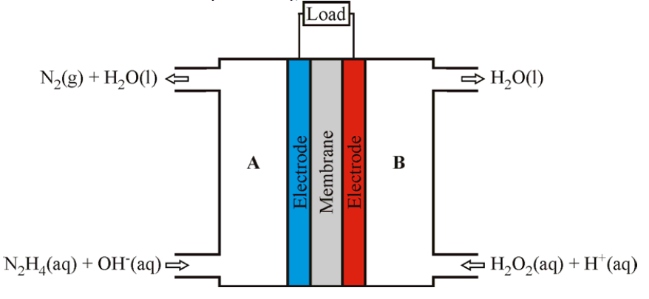

half
-cell
B
half
-cell
A

  - Show how the oxidation number of oxygen in half-cell B changes during operation.
+1 -1 +1 -2
H₂O₂ → H₂O
+2 -2 +2 -2

The oxidation number of oxygen in half cell B decreases from –1 in H₂O₂ to -2 in H₂O.

1 mark

  - Show in the box on the diagram the direction of electron flow through the load during operation.
1 mark

  - Write the half-equation for the hydrazine, N₂H₄, reaction that occurs during operation in half-cell A.
K N₂H₄(aq) → N₂(g)
O N₂H₄(aq) → N₂(g)
H N₂H₄(aq) → N₂(g) + 4H⁺
OH⁻ alkaline N₂H₄(aq) + 4OH⁻ → N₂(g) + 4H⁺ + 4OH⁻
E N₂H₄(aq) + 4OH⁻ → N₂(g) + 4H₂O + 4e⁻
S N₂H₄(aq) + 4OH⁻(aq) → N₂(g) + 4H₂O(l) + 4e⁻

1 mark correct balanced half-equation for either alkaline or acidic
1 mark correct balanced half-equation for alkaline
2 mark

- NASA is investigating hydrogen–oxygen proton exchange membrane (PEM) fuel cells to provide reliable, compact and high-energy power sources for aerospace applications.
- The electrical energy produced by the oxidation of hydrogen (H₂) in this cell is 155 kJ mol⁻¹. Calculate the volume of hydrogen gas, in litres at 75°C and 120 kPa, that would be required to produce 400 MJ of electrical energy from this fuel cell.

n(H₂) = $\frac{400 MJ ×1000}{155 kJ{mol}^{-1}}=2581 mol$ 1 mark

$$V=\frac{nRT}{p}=\frac{2581mol ×8.31J{mol}^{-1}K^{-1}×(75+273)K}{120kPa}=62191L=62200L or 6.22×{10}^{4}L$$
1 mark
2 marks

- Explain one barrier to the widespread adoption of hydrogen as a fuel.
Any one of:
Widespread adoption of hydrogen requires significant expenditure on infrastructure.
Most hydrogen produced has a lower energy content than the original fuel and production releases greenhouse gases.
Hydrogen-air mixtures can ignite with very low energy input.
Hydrogen is highly flammability, even at low (4% by volume) concentrations in air.
Hydrogen can explode when ignited at a wide range (18 to 59% by volume) of concentrations in air.
Hydrogen is odourless, colourless and tasteless, so most human senses won't help to detect a leak.
Other valid barrier.

1 marks

END of TASK 2

